NUCA’s Damage Prevention and Claims Avoidance Program has saved members more than $5.7 million since the program began in 2007.
Hits Got You Down?
NUCA’s Damage Prevention and Claims Avoidance Program Has Your Back
Consulting exclusively for NUCA members.
Utility contractors engaged in excavation unnecessarily lose millions of damage-related dollars each year. Here’s why:
- Many contractor’s damage investigations are poor or nonexistent, which gives them nothing to fight utility clams
- Contractors pay utility damage claims that they are not liable for
- Contractors fail to bill for crew and equipment downtime while waiting for utility locates that should have been done before the crews arrived.
If this sounds like you, then you need to take advantage of NUCA’s Damage Prevention and Claims Avoidance Program. This benefit is an exclusive arrangement between Ron Peterson Consulting, LLC and NUCA members.

The three-tiered program offers free Best Practices Consulting and Damage Investigation Consulting. Members receive one free hour for Claims Evaluation Consulting per quarter, or a total of four free hours each year. Each additional hour of consulting per quarter will be offered at the significantly discounted member rate of $75 per hour (standard rates are $300 an hour).
Members can select from any or all the following three-tiered services.
Damage Prevention Best Practices Consulting covers best practices in damage prevention (design phase through backfill, pre-excavation documentation, and state one-call laws). This service is free to NUCA members.
Damage Investigation Consultation provides the tools contractors need to conduct their own detailed damage investigation should the company need to challenge an unwarranted damage claim, including consulting on what should be photographed and how, evidence gathering, documentation, liability determinations, and negotiations. This service is free to NUCA members.
Claims Evaluation Consulting provides assistance when a contractor believes a claim is unwarranted. Some claims can be hundreds of pages long—prompting contractors to pay the claim and move on, regardless of the merits
of the claim. The NUCA consultant will evaluate damage claims for you and help you make the best decisions on how to respond. Members receive one free hour a quarter, additional hours only $75 an hour.

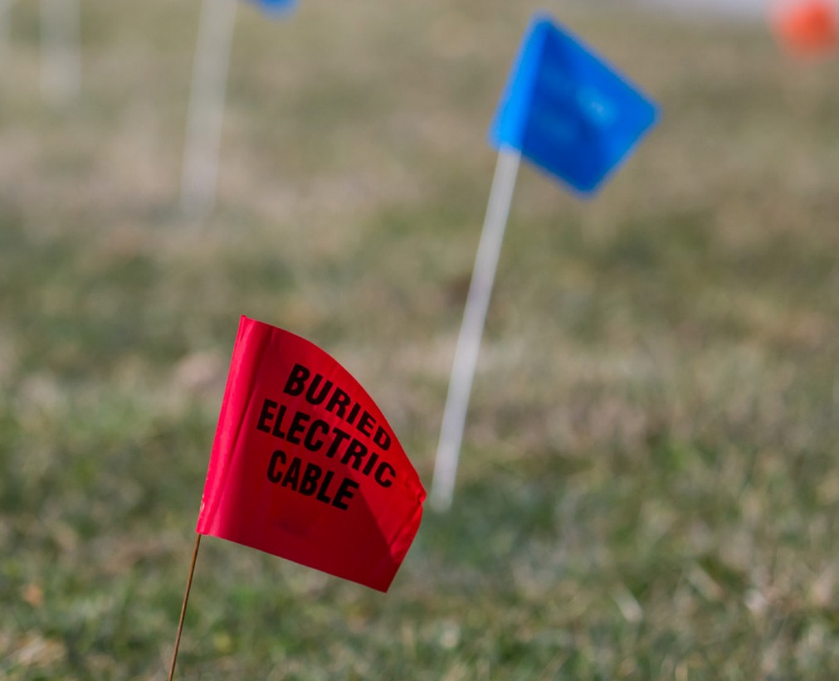
(over)

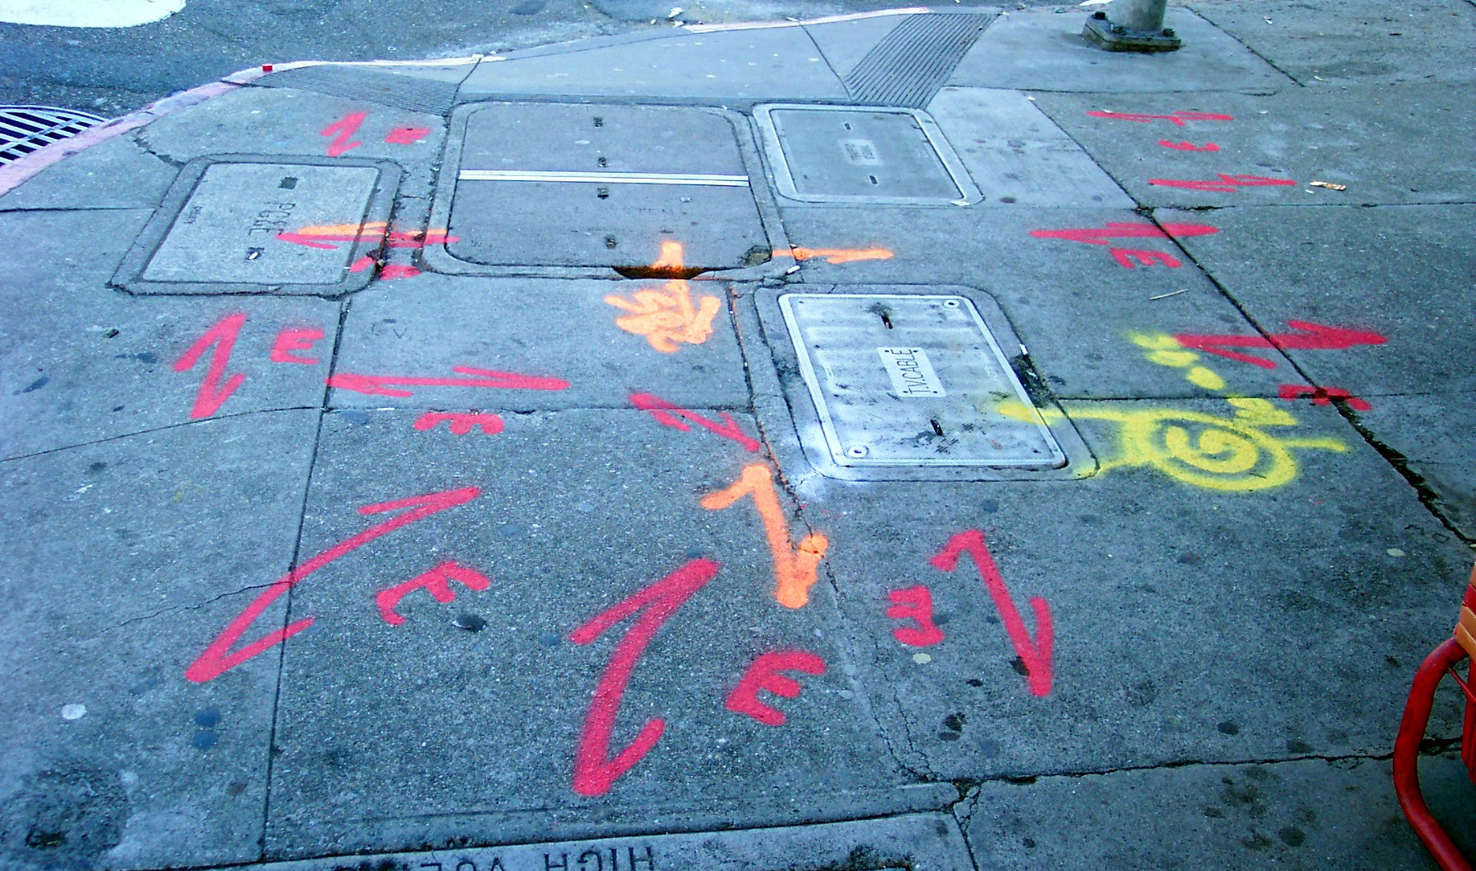

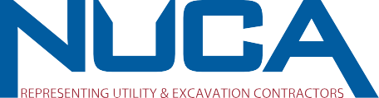Since the program began in 2007, the program has saved members more than $5.7 million—most resulting from reduced, overturned, owner reimbursement to the contractor for repairs not caused by the contractor.

This material (“Material”) is licensed to Ron Peterson Consulting, LLC for use only in strict accordance with the License Agreement with NUCA, as amended or modified from time to time. No part of the Material may be reproduced, stored in a retrieval system, or transmitted in any form, without the prior written permission of NUCA. Reference to any product, process, or service by Ron Peterson Consulting, LLC does not constitute or imply an endorsement or recommendation by NUCA of the product, process, or service, or its producer or provider. The views and opinions expressed in the Material do not necessarily state or reflect those of NUCA. NUCA does not make any warranty, express or implied, including warranties of merchantability and fitness for a particular purpose, or assumes legal liability for the accuracy, completeness,
or usefulness of any information contained in the Material.

“This program provides peace of mind and saves excavators a lot of time, energy, and money when it comes to tough decisions surrounding facility damage investigation and claims— and this benefit is exclusively for NUCA members!”
Bill Hillman, NUCA, CEO
Don’t wait for the next bill to arrive, contact Ron Peterson and find out how to protect yourself against unwarranted claims.
Free consulting is an exclusive NUCA member benefit.

NUCA member Ron Peterson is President of Ron Peterson Consulting, LLC, a Kansas City-based company specializing in damage prevention training and consulting. Prior to consulting, Ron spent many years working for both locators and utilities managing claims operations, including internal claims for construction in several states. He has also been responsible for developing training curriculum and damage investigating training, as well as claims review. He also spent several years in the insurance industry. Ron may be reached by email: ron@ronpetersonconsulting.com or by phone 816.985.4436.

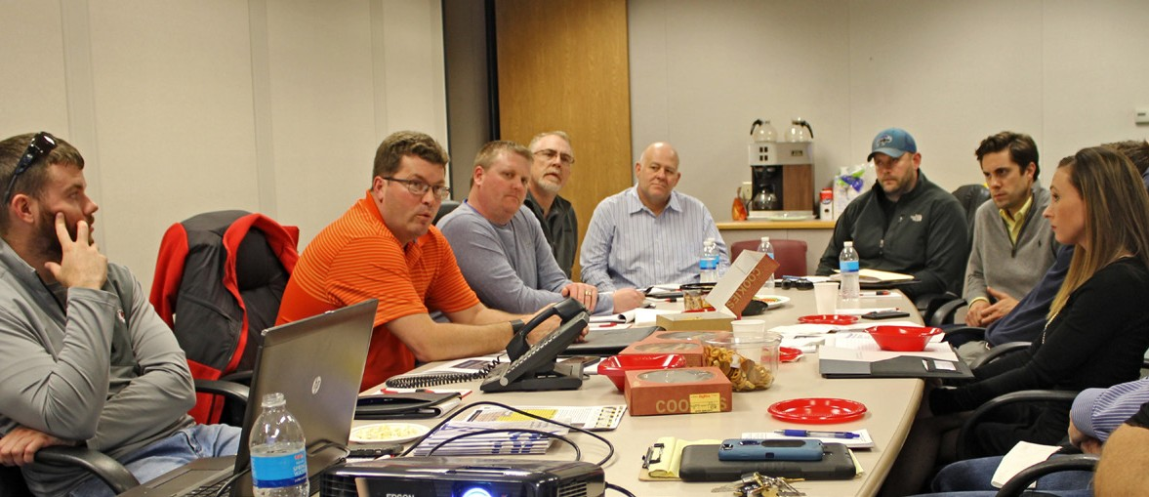
Ron Peterson (orange shirt) holds a damage prevention best practices consulting session with NUCA of Greater Kansas City Region members.

